**Storage Report**

I added storage part to Lab 2. Lab 2 is on weather report. It gives weather conditions of Kansas City.

The Storage part will store the weather data and display it whenever needed and we can also remove the data if it is not required. The remove, load, display buttons are added for deleting, storing and displaying the data (weather conditions) respectively.

The screenshots are:

1. This shows the storage button options.

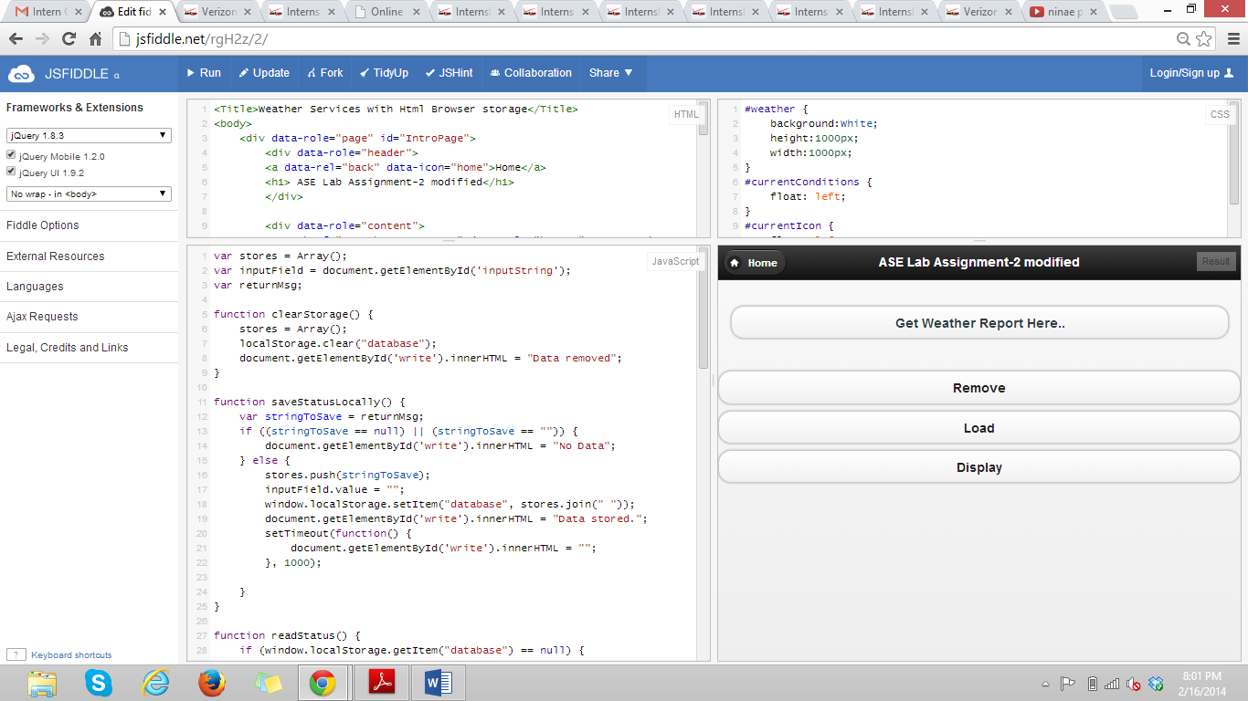

1. The current weather report is displayed. We can remove or display or store it.

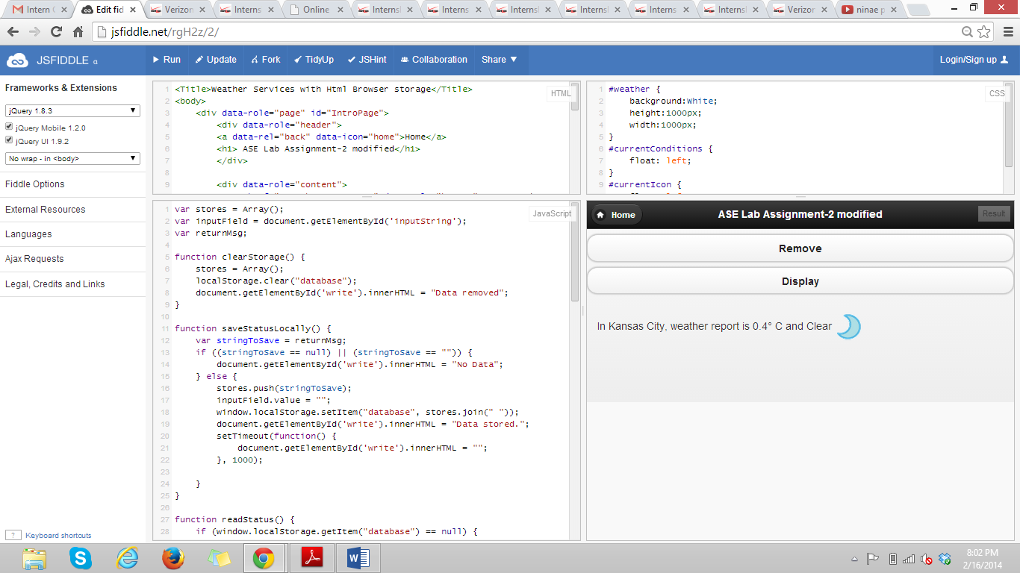

1. If no data is stored then it displays the same.

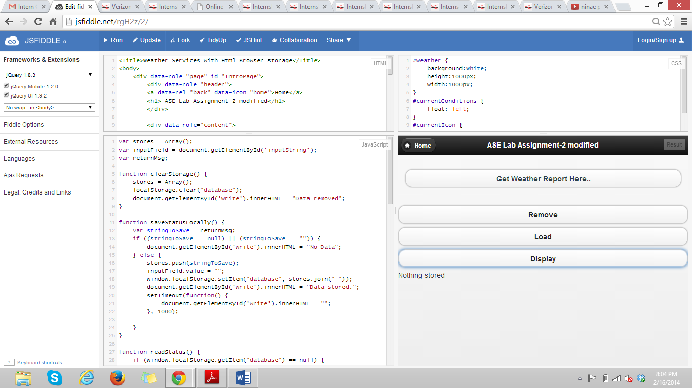

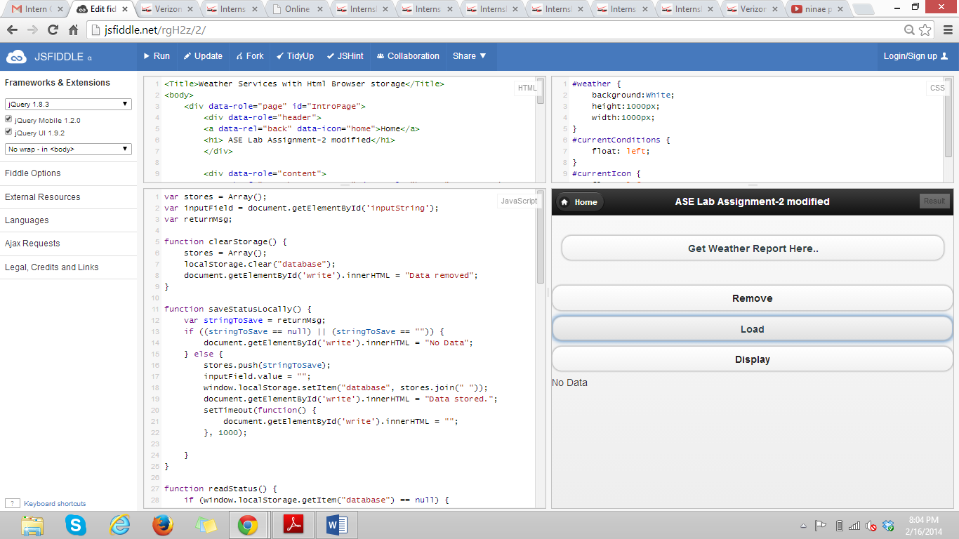

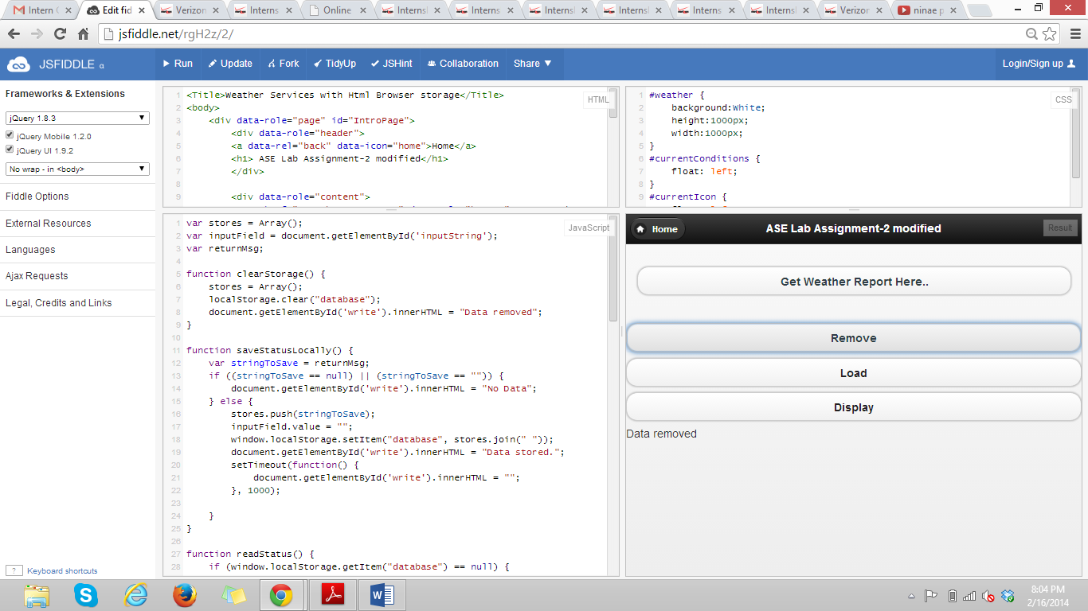

1. When data is displayed.

